WEEK 5

Mandatory Hands-On

**Microservices using Spring Boot (RESTful)**

**Creating Microservices for account and loan**

**Account Microservice:**

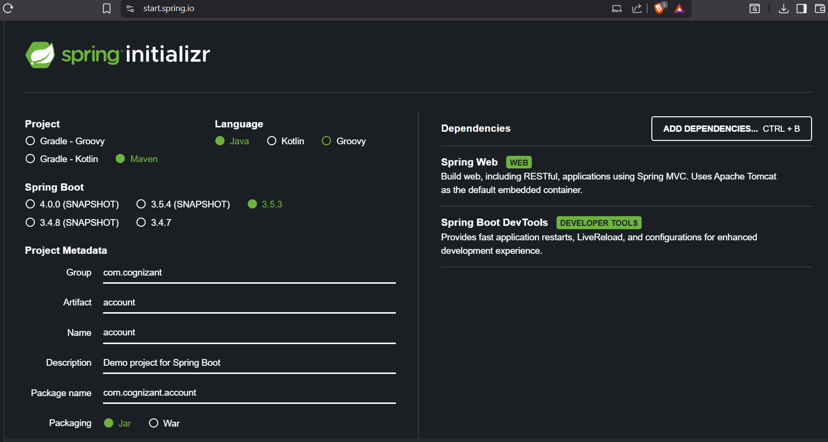

* The project is generated and downloaded into microservices folder in C: drive.
* The project is run using *mvn clean package.*
* Then the project is imported to the eclipse work-space.

**AccountController Class:**

* AccountController Class is created under the package *com.cognizant.account.AccountController.*

**AccountController.java:**

package com.cognizant.account.controller;

import org.springframework.web.bind.annotation.*;

*@RestController*

*@RequestMapping*("/accounts")

public class AccountController {

*@GetMapping*("/{number}")

public Account getAccount(*@PathVariable* String number) {

return new Account(number, "savings", 234343);

}

record Account(String number, String type, double balance) {}

}

**Main Class:**

**AccountApplication.java:**

package com.cognizant.account;

import org.springframework.boot.SpringApplication;

import org.springframework.boot.autoconfigure.SpringBootApplication;

*@SpringBootApplication*

public class AccountApplication {

public static void main(String[] args) {

SpringApplication.*run*(AccountApplication.class, args);

}

}

**Sample Output:**

* In <http://localhost:8080/accounts/00987987973432>
* 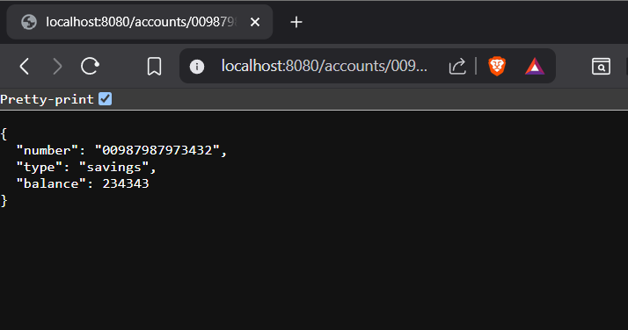Where server.port is set to 8080.

**Loan Microservice:**

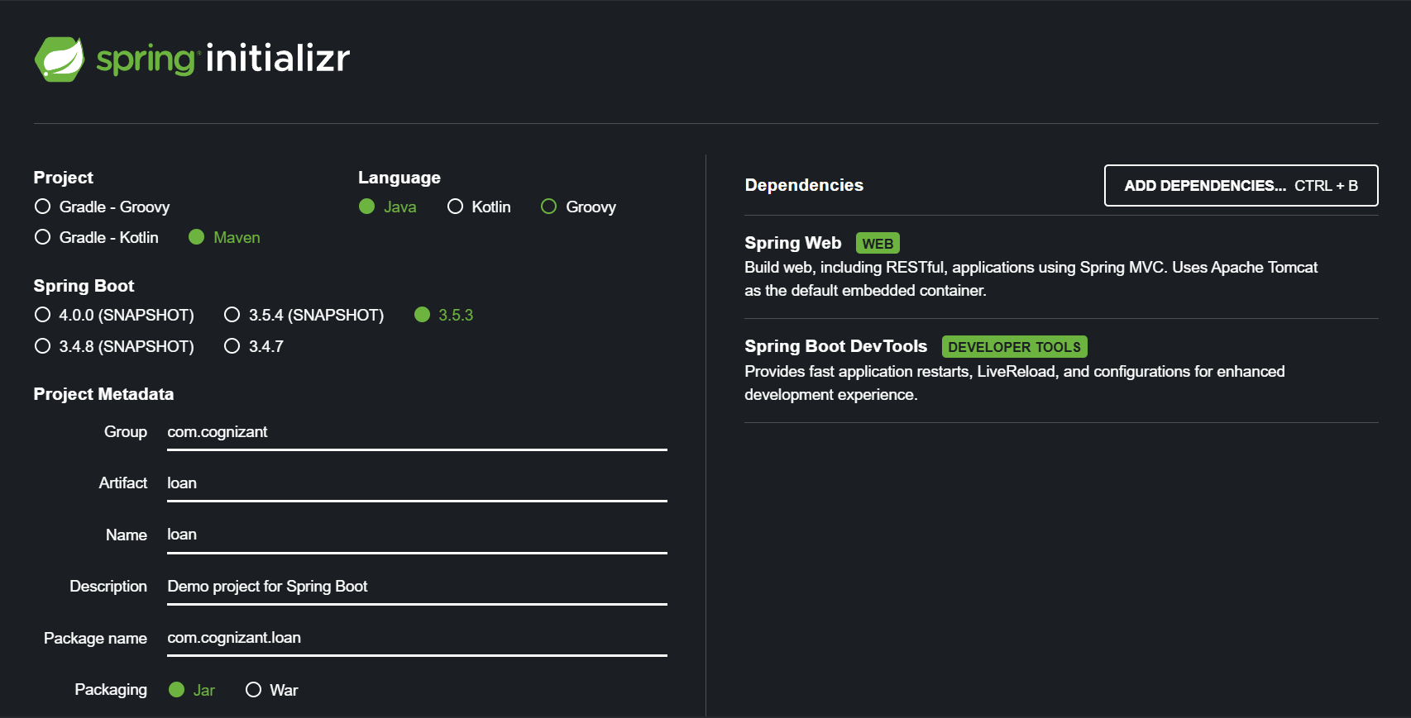

* The project is generated and downloaded into microservices folder in C: drive.
* The project is run using *mvn clean package.*
* Then the project is imported to the eclipse work-space.

**LoanController Class:**

* LoanController Class is created under the package *com.cognizant.account.Loan Controller.*

**LoanController.java:**

package com.cognizant.loan.controller;

import org.springframework.web.bind.annotation.*;

@RestController

@RequestMapping("/loans")

public class LoanController {

@GetMapping("/{number}")

public Loan getLoan(@PathVariable String number) {

return new Loan(number, "car", 400000, 3258, 18);

}

record Loan(String number, String type, double loan, double emi, int tenure) {}

}

**Main Class:**

**LoanApplication.java:**

package com.cognizant.loan;

import org.springframework.boot.SpringApplication;

import org.springframework.boot.autoconfigure.SpringBootApplication;

*@SpringBootApplication*

public class LoanApplication {

public static void main(String[] args) {

SpringApplication.*run*(LoanApplication.class, args);

}

}

**Sample Output:**

* In <http://localhost:8081/loans/H00987987972342>
* Where server.port is set to 8081.

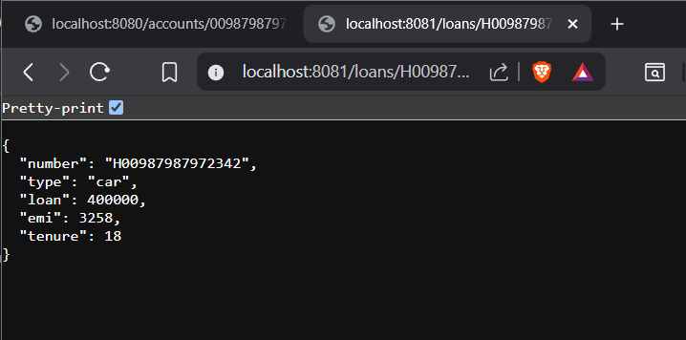

**NOTE:**

* Two independent Spring Boot microservices running on different ports.
* AccountApplication microservice in localhost-8080.
* LoanApplication microservice in localhost-8081.